Geometric Transformations

Definition
# Source: AI Source: Provided by: [Data Path: Persons Table -> ID Column: 1, Name_En Column: Motasem Essam] -> From: [ChatGPT] on [7/25/2026]
Geometric Transformations are operations that move, turn, flip, or resize a geometric figure to produce a new figure.
A transformation changes the position, orientation, or size of a figure according to specific mathematical rules.
The original figure is called the preimage, and the resulting figure is called the image.
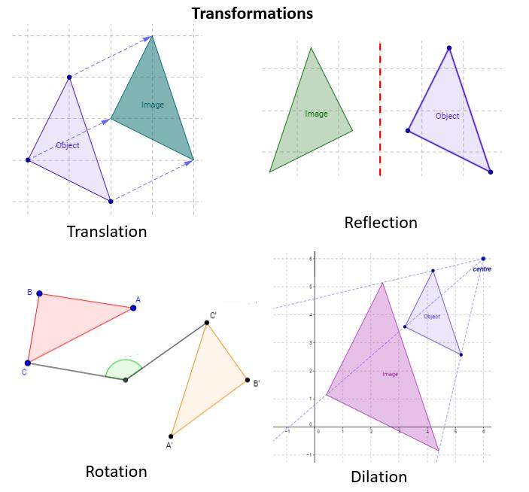
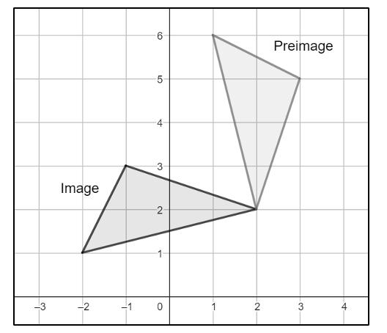
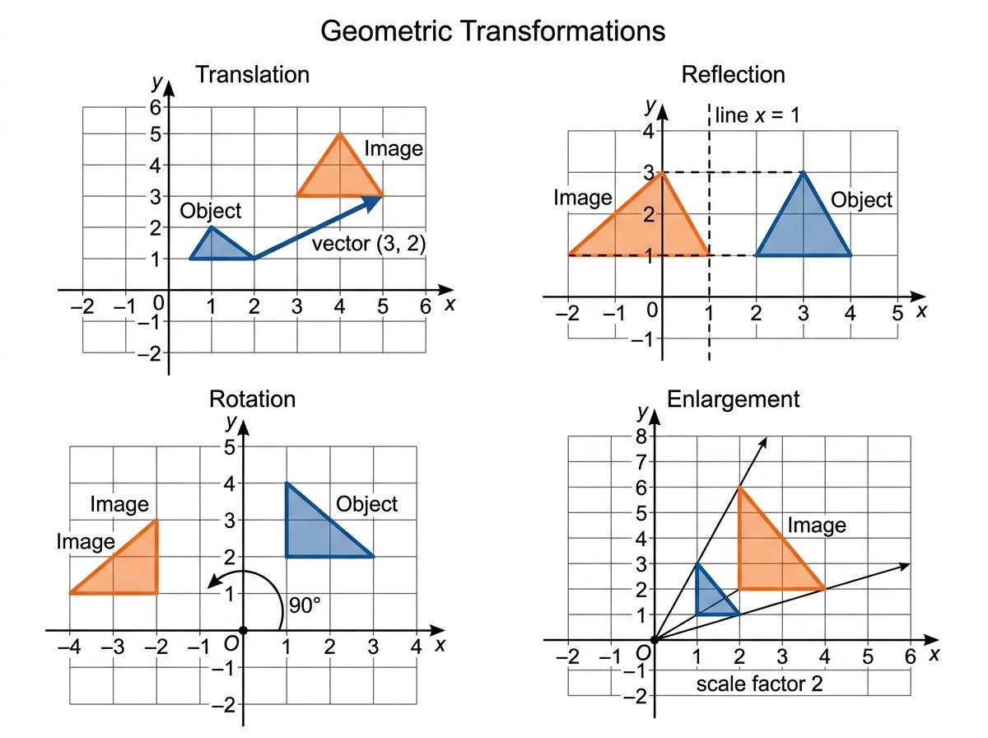
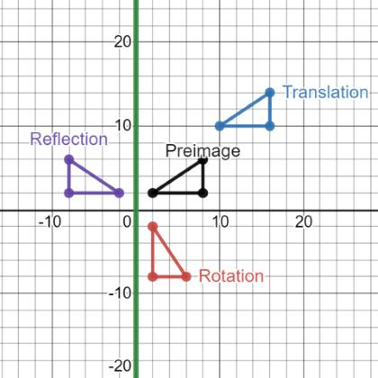
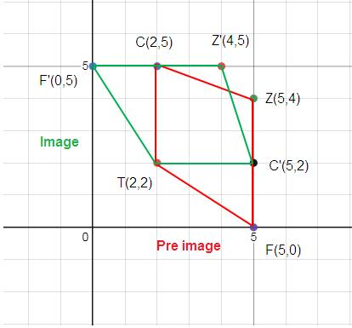
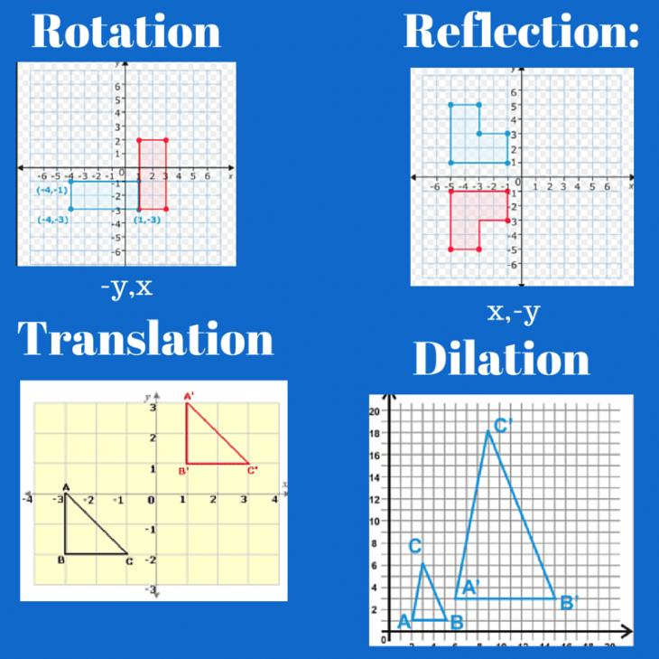

Purpose
# Source: AI Source: Provided by: [Data Path: Persons Table -> ID Column: 1, Name_En Column: Motasem Essam] -> From: [ChatGPT] on [7/25/2026]
Geometric transformations are used to:
- Move geometric figures.
- Rotate figures around a point.
- Reflect figures across a line.
- Enlarge or reduce figures.
- Study changes in position and orientation.
- Analyze congruence and similarity.
- Describe symmetry.
- Solve coordinate geometry problems.
- Model movements in computer graphics and engineering.

Fundamental Concepts
# Source: AI Source: Provided by: [Data Path: Persons Table -> ID Column: 1, Name_En Column: Motasem Essam] -> From: [ChatGPT] on [7/25/2026]
A transformation involves two main figures:

Preimage
# Source: AI Source: Provided by: [Data Path: Persons Table -> ID Column: 1, Name_En Column: Motasem Essam] -> From: [ChatGPT] on [7/25/2026]
The preimage is the original figure before the transformation.
It is commonly labeled using letters such as:
$$A, B, C$$

Image
# Source: AI Source: Provided by: [Data Path: Persons Table -> ID Column: 1, Name_En Column: Motasem Essam] -> From: [ChatGPT] on [7/25/2026]
The image is the figure obtained after the transformation.
Image points are commonly labeled with primes:
$$A', B', C'$$
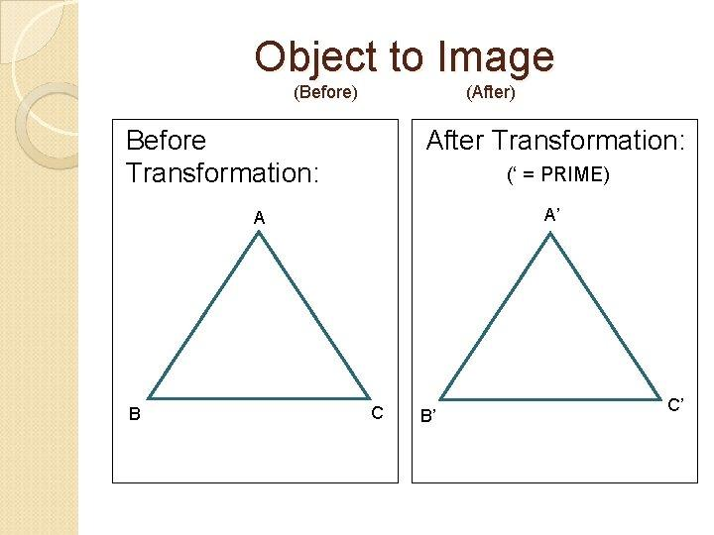
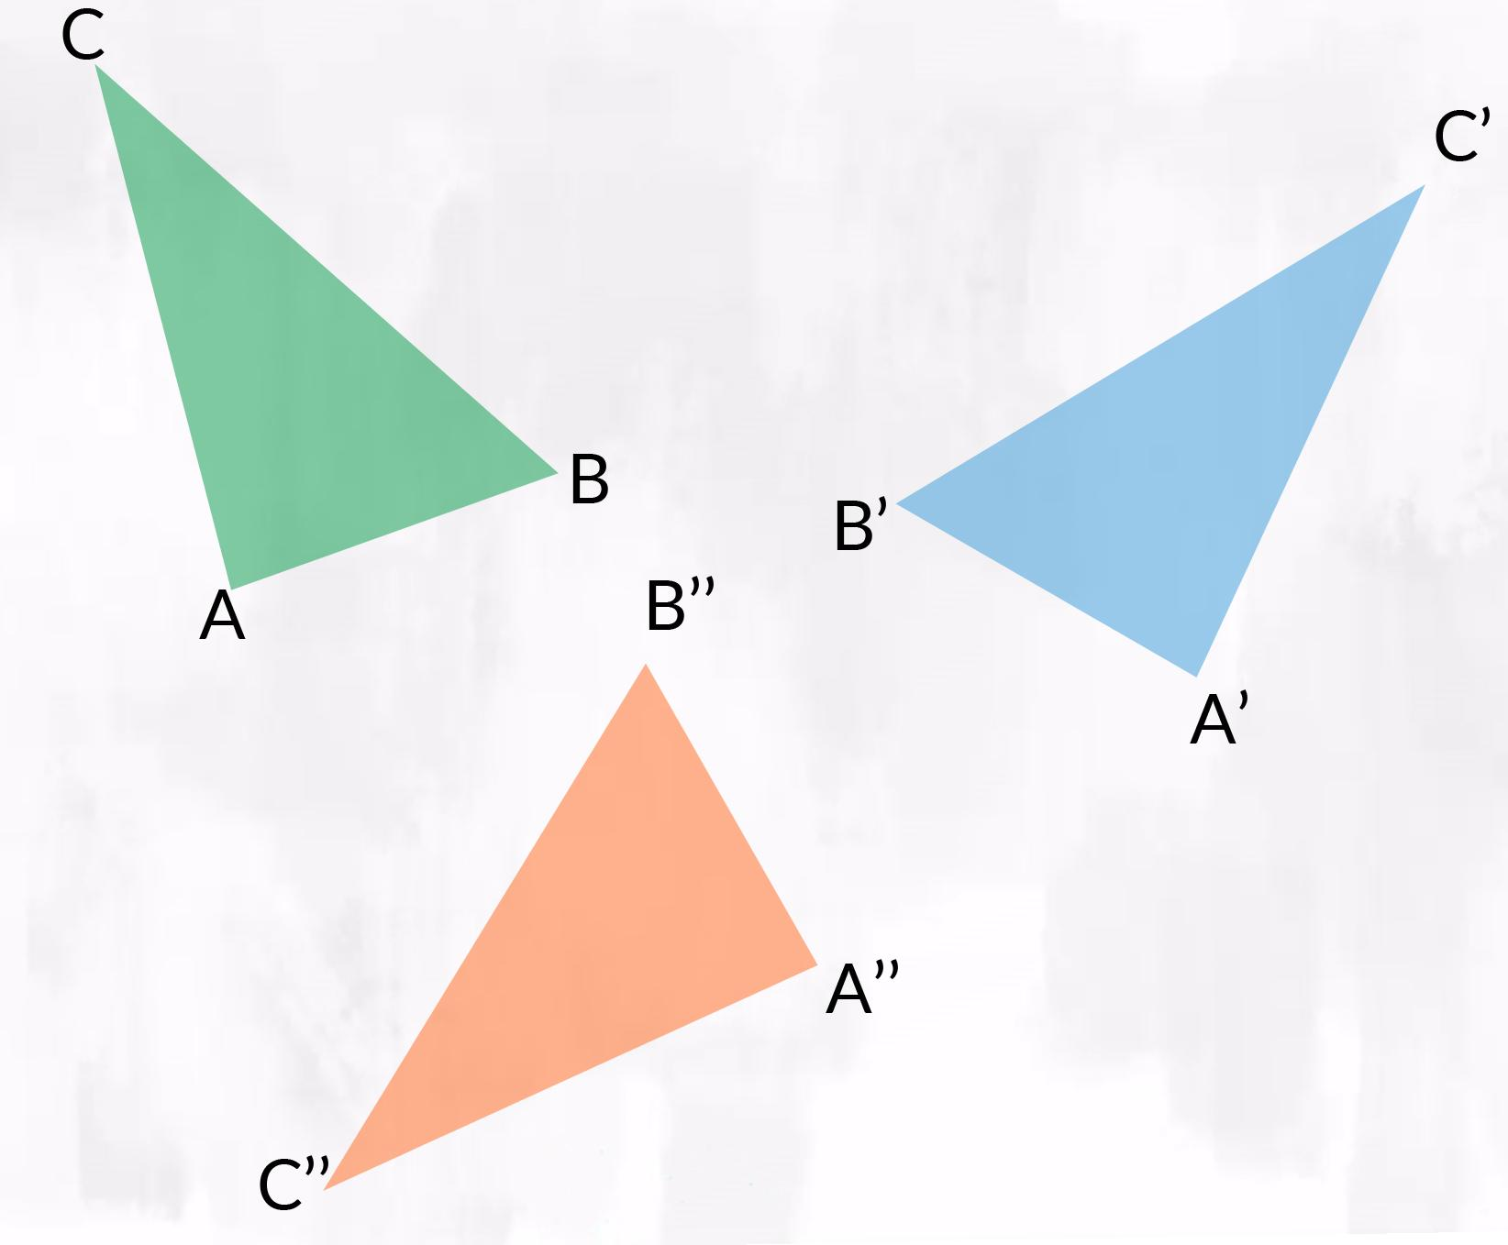
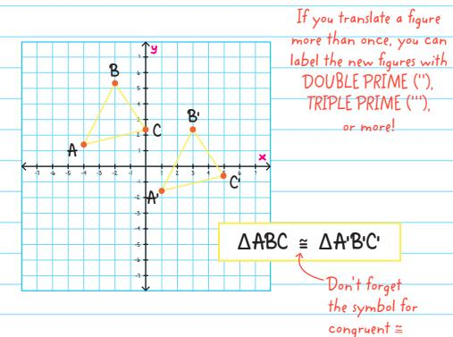
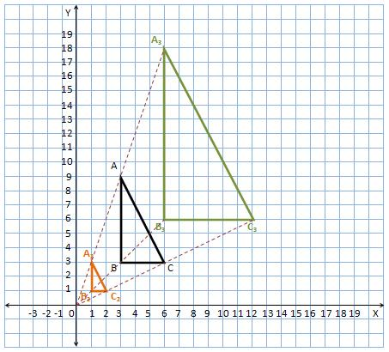

Types of Geometric Transformations
# Source: AI Source: Provided by: [Data Path: Persons Table -> ID Column: 1, Name_En Column: Motasem Essam] -> From: [ChatGPT] on [7/25/2026]
The four fundamental transformations are:
- Translation
- Rotation
- Reflection
- Dilation
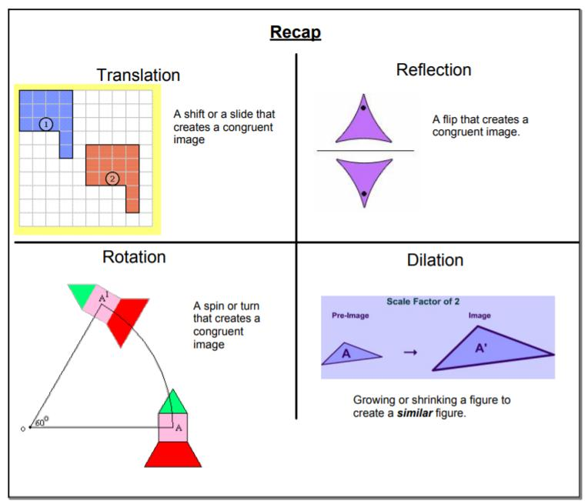
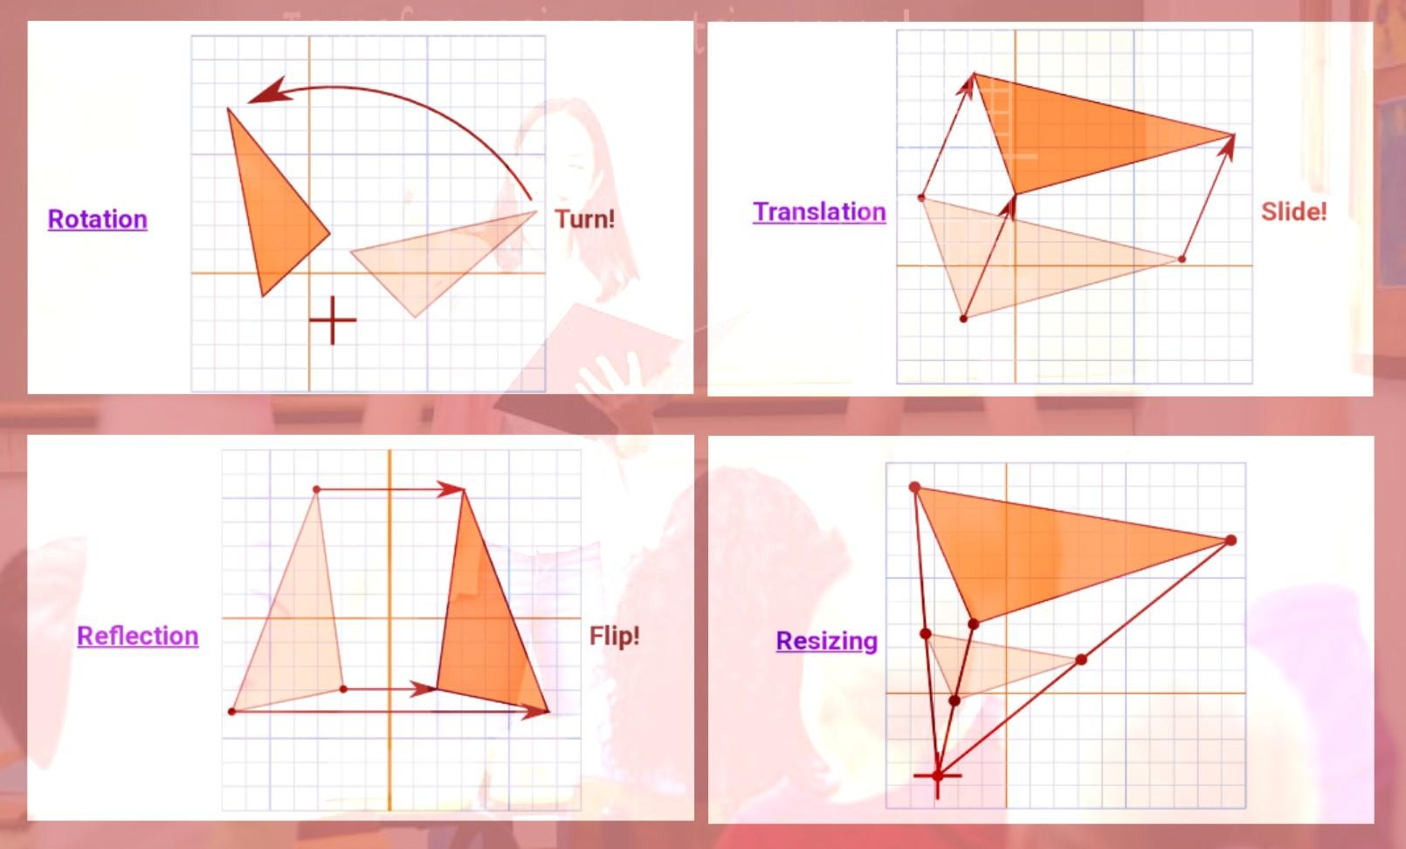
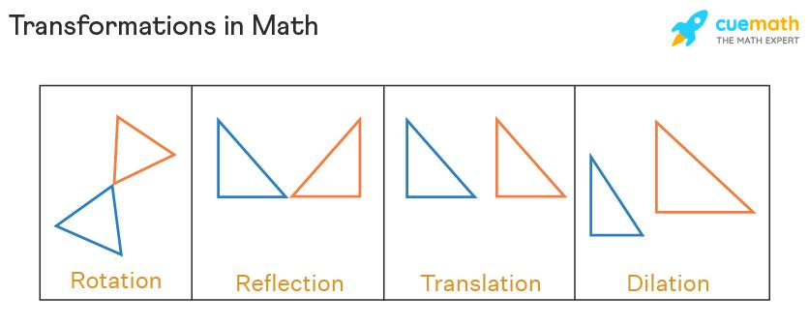

1. Translation
# Source: AI Source: Provided by: [Data Path: Persons Table -> ID Column: 1, Name_En Column: Motasem Essam] -> From: [ChatGPT] on [7/25/2026]
Definition
Translation is a transformation that moves every point of a figure the same distance in the same direction.
A translation does not rotate, reflect, or resize the figure.
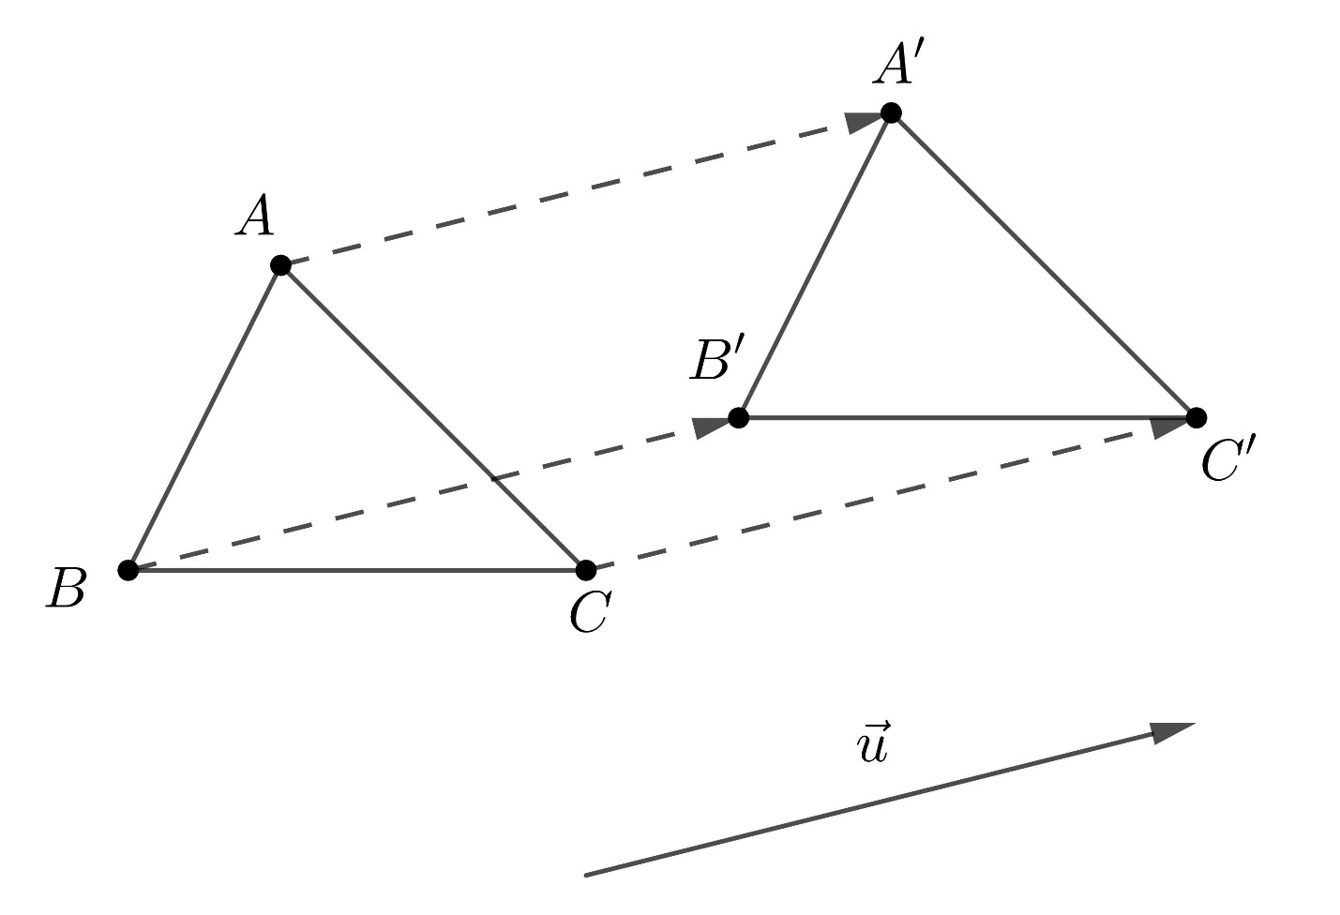
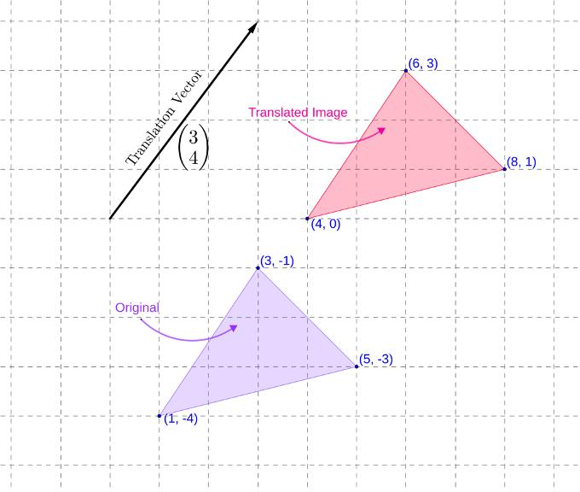
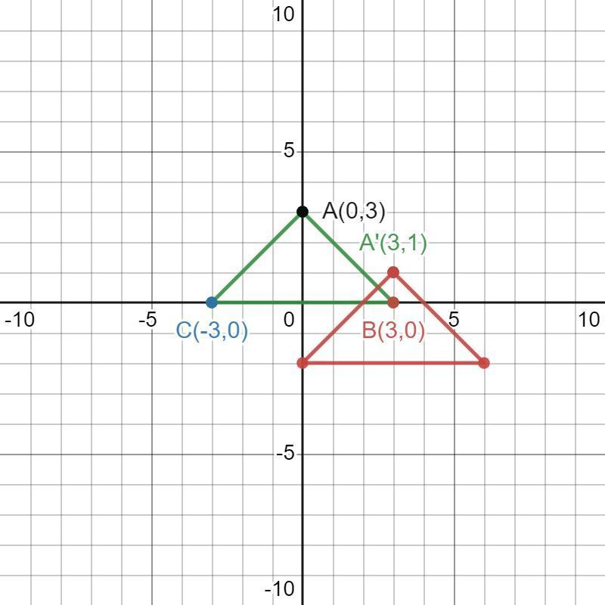
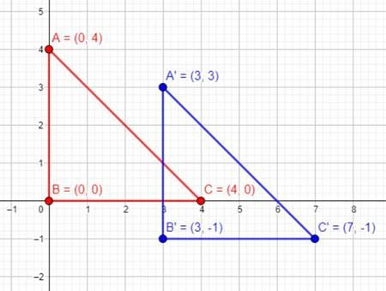
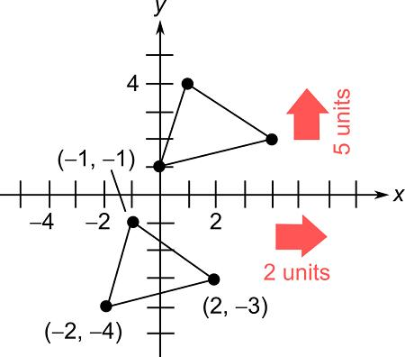
Coordinate Rule
A translation can be represented by:
$$\boxed{\left(x,y\right)→\left(x+a,y+b\right)}$$
where:
- $a$ = horizontal movement.
- $b$ = vertical movement.
For example:
$$\left(x,y\right)→\left(x+3,y+2\right)$$
moves a figure:
- $3$ units right.
- $2$ units up.
Properties
Translation preserves:
- Shape.
- Size.
- Lengths.
- Angles.
- Parallelism.
- Orientation.
Therefore, a figure and its translated image are congruent.

2. Rotation
# Source: AI Source: Provided by: [Data Path: Persons Table -> ID Column: 1, Name_En Column: Motasem Essam] -> From: [ChatGPT] on [7/25/2026]
Definition
Rotation is a transformation that turns a figure around a fixed point through a specified angle.
The fixed point is called the center of rotation.
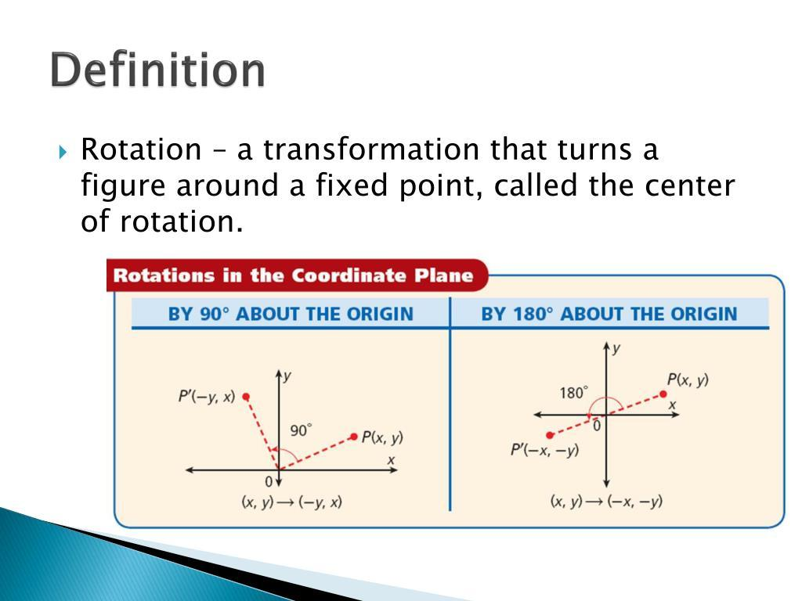
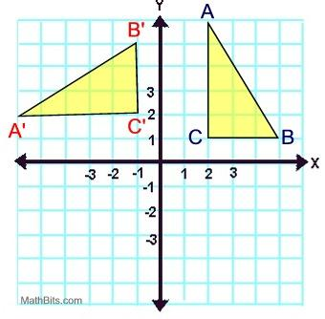
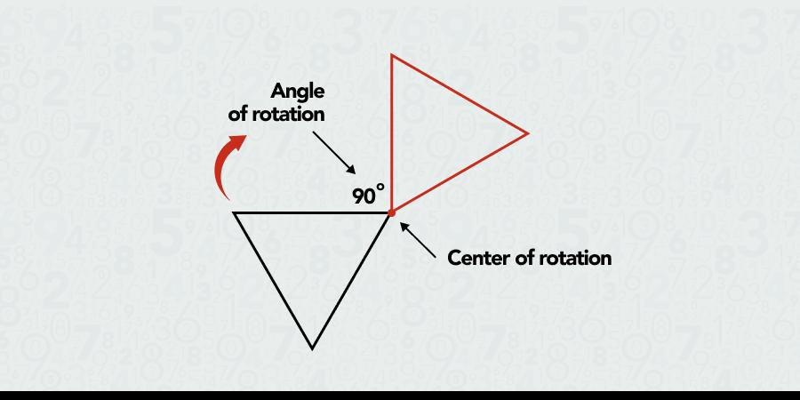
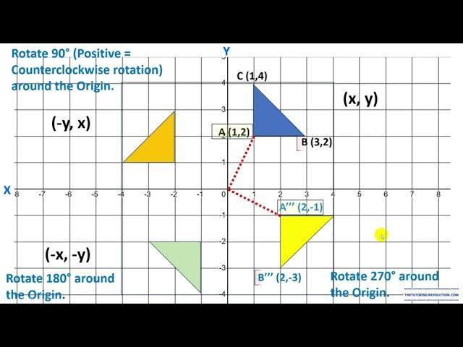
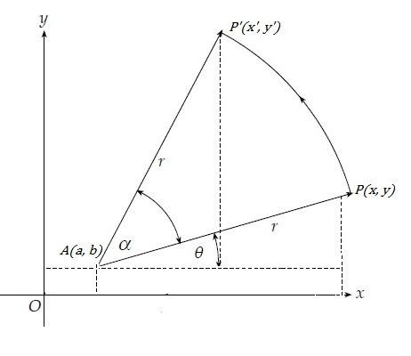
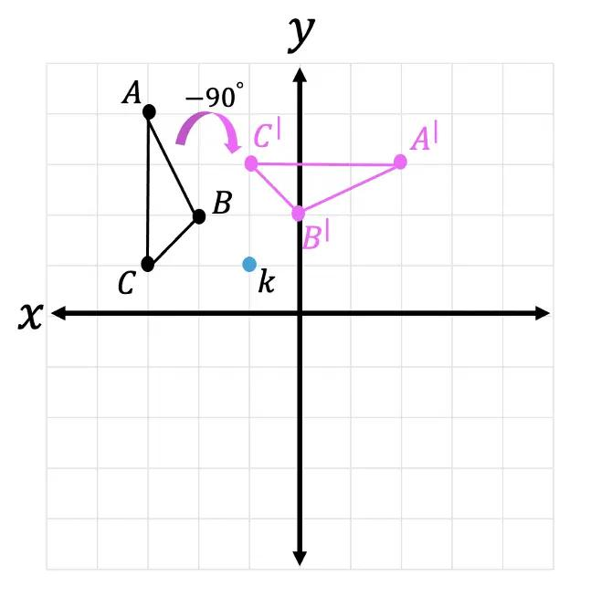
A rotation can be:
- Clockwise.
- Counterclockwise.
Common rotation angles include:
$${90}^{∘}, {180}^{∘}, {270}^{∘}, {360}^{∘}$$
Rotation About the Origin
For a ${90}^{∘}$ counterclockwise rotation:
$$\boxed{\left(x,y\right)→\left(-y,x\right)}$$
For a ${180}^{∘}$ rotation:
$$\boxed{\left(x,y\right)→\left(-x,-y\right)}$$
For a ${270}^{∘}$ counterclockwise rotation:
$$\boxed{\left(x,y\right)→\left(y,-x\right)}$$
Properties
Rotation preserves:
- Shape.
- Size.
- Lengths.
- Angles.
- Area.
Therefore, a rotated figure is congruent to its original figure.

3. Reflection
# Source: AI Source: Provided by: [Data Path: Persons Table -> ID Column: 1, Name_En Column: Motasem Essam] -> From: [ChatGPT] on [7/25/2026]
Definition
Reflection is a transformation that flips a figure across a line called the line of reflection.
The resulting image is a mirror image of the original figure.
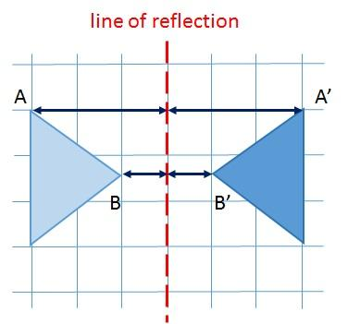
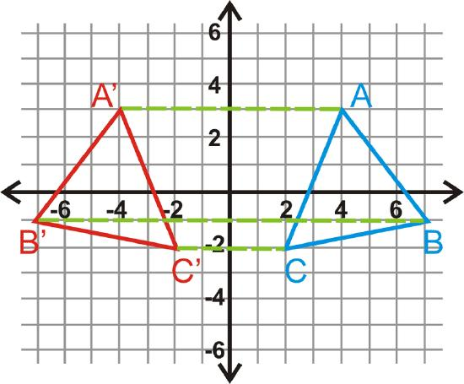
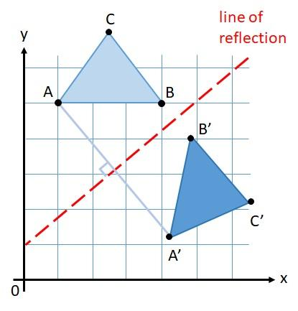
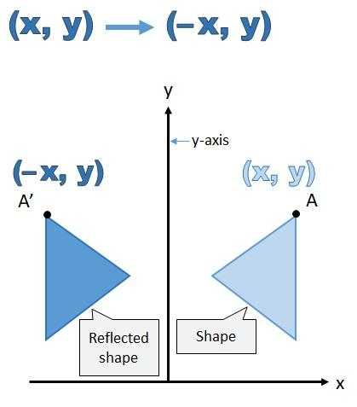
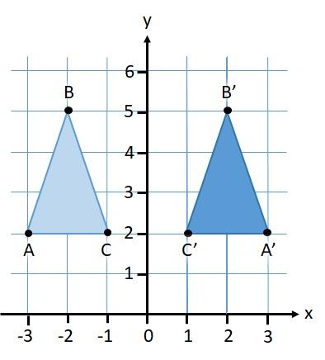
Common Reflection Rules
Reflection across the $x$-axis:
$$\boxed{\left(x,y\right)→\left(x,-y\right)}$$
Reflection across the $y$-axis:
$$\boxed{\left(x,y\right)→\left(-x,y\right)}$$
Reflection through the origin:
$$\boxed{\left(x,y\right)→\left(-x,-y\right)}$$
Properties
Reflection preserves:
- Shape.
- Size.
- Lengths.
- Angle measures.
- Area.
However, reflection reverses orientation.

4. Dilation
# Source: AI Source: Provided by: [Data Path: Persons Table -> ID Column: 1, Name_En Column: Motasem Essam] -> From: [ChatGPT] on [7/25/2026]
Definition
Dilation is a transformation that enlarges or reduces a figure according to a scale factor.
Unlike translation, rotation, and reflection, dilation can change the size of the figure.
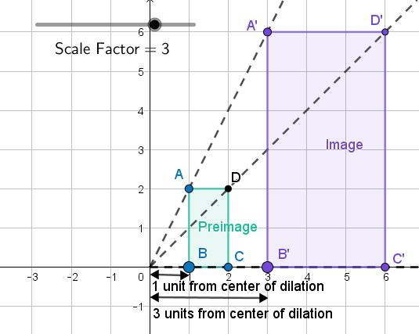
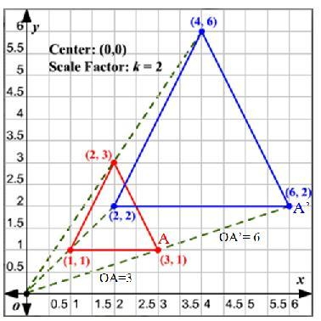
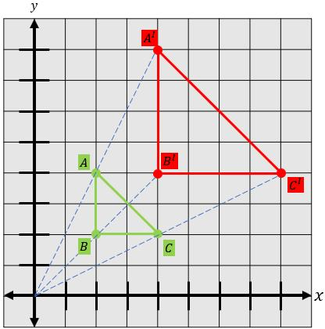
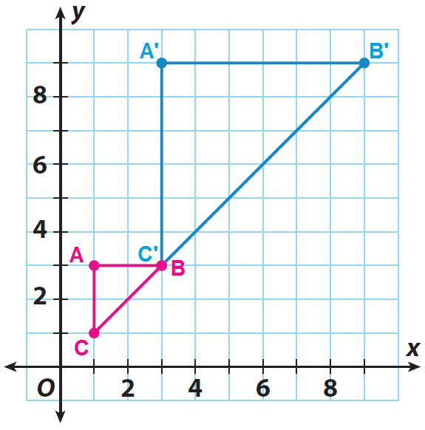
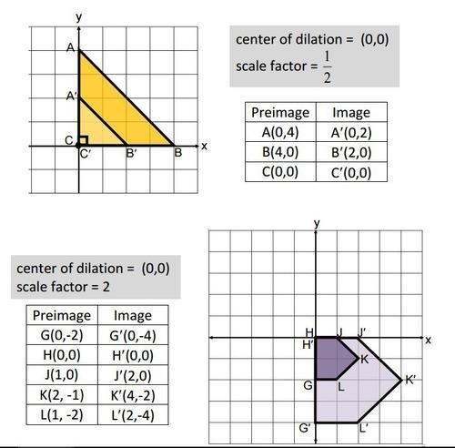
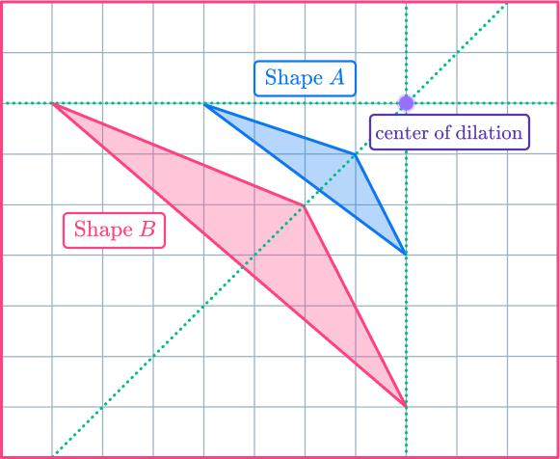
Coordinate Rule
For a dilation centered at the origin:
$$\boxed{\left(x,y\right)→\left(kx,ky\right)}$$
where $k$ is the scale factor.
Scale Factor
If:
$$k>1$$
the figure is enlarged.
If:
$$0<k<1$$
the figure is reduced.
If:
$$k=1$$
the figure remains the same size.
Example
For:
$$k=2$$
the transformation is:
$$\left(x,y\right)→\left(2x,2y\right)$$
Every distance from the center is doubled.
Properties
Dilation preserves:
- Shape.
- Angle measures.
- Proportionality.
But generally does not preserve:
- Side lengths.
- Perimeter.
- Area.
Therefore, a dilated figure is generally similar, rather than congruent, to the original figure.

Rigid Transformations
# Source: AI Source: Provided by: [Data Path: Persons Table -> ID Column: 1, Name_En Column: Motasem Essam] -> From: [ChatGPT] on [7/25/2026]
A rigid transformation is a transformation that preserves distances and angles.
The three main rigid transformations are:
- Translation
- Rotation
- Reflection
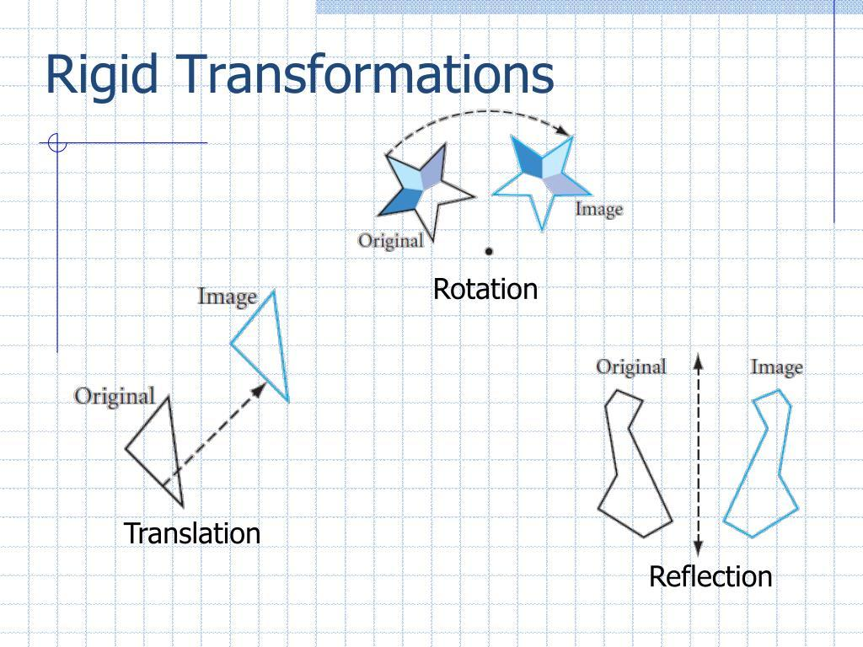
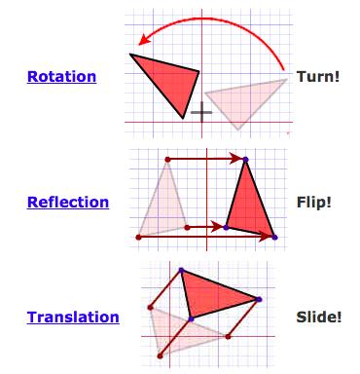
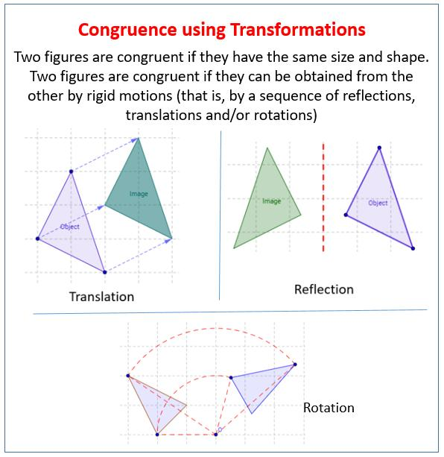
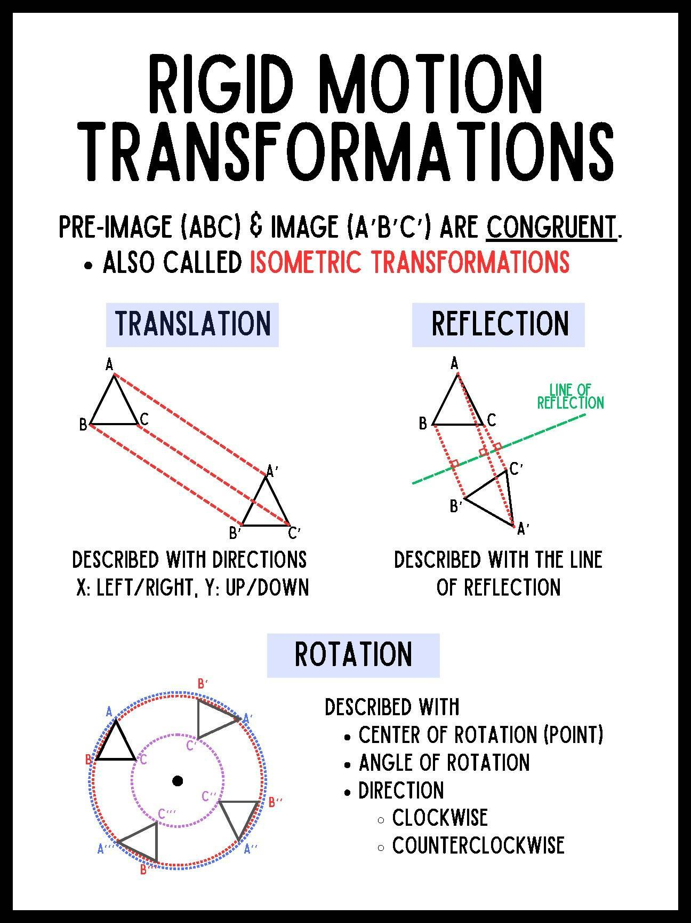
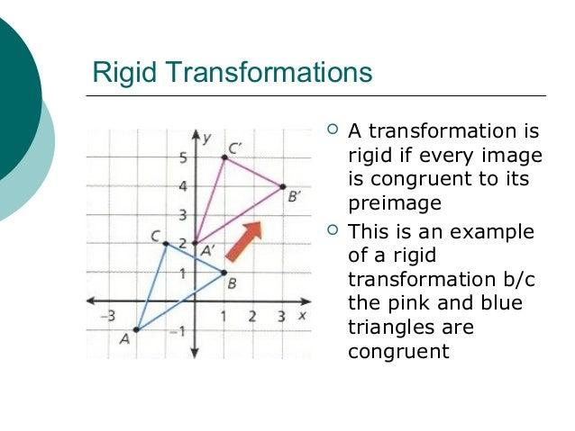
These transformations preserve:
$$\boxed{\text{Length, Angle, Area, and Shape}}$$
Therefore:
$$\text{Preimage}≅\text{Image}$$

Non-Rigid Transformation
# Source: AI Source: Provided by: [Data Path: Persons Table -> ID Column: 1, Name_En Column: Motasem Essam] -> From: [ChatGPT] on [7/25/2026]
Dilation
Dilation is generally considered a non-rigid transformation because it can change the size of a figure.
It preserves:
- Shape.
- Angle measures.
- Ratios of corresponding lengths.
But changes:
- Length.
- Perimeter.
- Area.
Thus:
$$\text{Preimage}∼\text{Image}$$
when the scale factor is not $1$.

Transformation Comparison
# Source: AI Source: Provided by: [Data Path: Persons Table -> ID Column: 1, Name_En Column: Motasem Essam] -> From: [ChatGPT] on [7/25/2026]
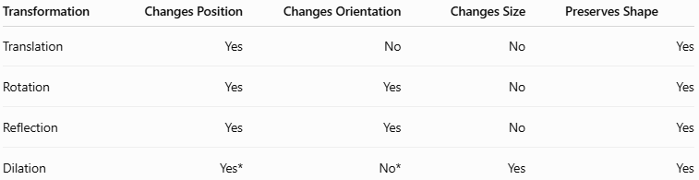
Transformation | Changes Position | Changes Orientation | Changes Size | Preserves Shape
Translation | Yes | No | No | Yes
Rotation | Yes | Yes | No | Yes
Reflection | Yes | Yes | No | Yes
Dilation | Yes* | No* | Yes | Yes
(Depending on the center and scale factor.)

Coordinate Transformation Rules
# Source: AI Source: Provided by: [Data Path: Persons Table -> ID Column: 1, Name_En Column: Motasem Essam] -> From: [ChatGPT] on [7/25/2026]
Some important rules are:
Translation
$$\left(x,y\right)→\left(x+a,y+b\right)$$
Reflection Across $x$-Axis
$$\left(x,y\right)→\left(x,-y\right)$$
Reflection Across $y$-Axis
$$\left(x,y\right)→\left(-x,y\right)$$
Rotation ${90}^{∘}$ Counterclockwise
$$\left(x,y\right)→\left(-y,x\right)$$
Rotation ${180}^{∘}$
$$\left(x,y\right)→\left(-x,-y\right)$$
Rotation ${270}^{∘}$ Counterclockwise
$$\left(x,y\right)→\left(y,-x\right)$$
Dilation About the Origin
$$\left(x,y\right)→\left(kx,ky\right)$$

Transformations and Congruence
# Source: AI Source: Provided by: [Data Path: Persons Table -> ID Column: 1, Name_En Column: Motasem Essam] -> From: [ChatGPT] on [7/25/2026]
Translation, rotation, and reflection preserve the size and shape of a figure.
Therefore:
$$\boxed{\text{Translation, Rotation, Reflection}⇒\text{Congruence}}$$
For example:
$$△ABC≅△A'B'C'$$
after a rigid transformation.

Transformations and Similarity
# Source: AI Source: Provided by: [Data Path: Persons Table -> ID Column: 1, Name_En Column: Motasem Essam] -> From: [ChatGPT] on [7/25/2026]
Dilation preserves the shape but may change the size.
Therefore:
$$\boxed{\text{Dilation}⇒\text{Similarity}}$$
For example:
$$△ABC∼△A'B'C'$$
when the image is an enlargement or reduction of the original.

Transformations and Symmetry
# Source: AI Source: Provided by: [Data Path: Persons Table -> ID Column: 1, Name_En Column: Motasem Essam] -> From: [ChatGPT] on [7/25/2026]
Transformations are also closely related to symmetry.
Line Symmetry
A figure has line symmetry when reflection across a particular line maps the figure onto itself.
Rotational Symmetry
A figure has rotational symmetry when rotation through certain angles maps the figure onto itself.
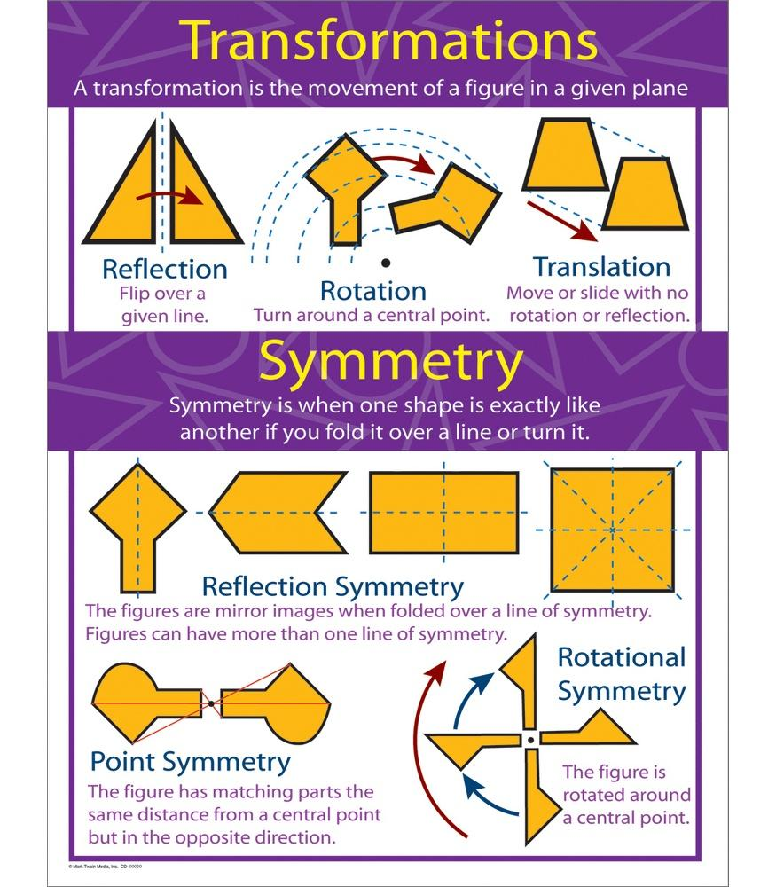
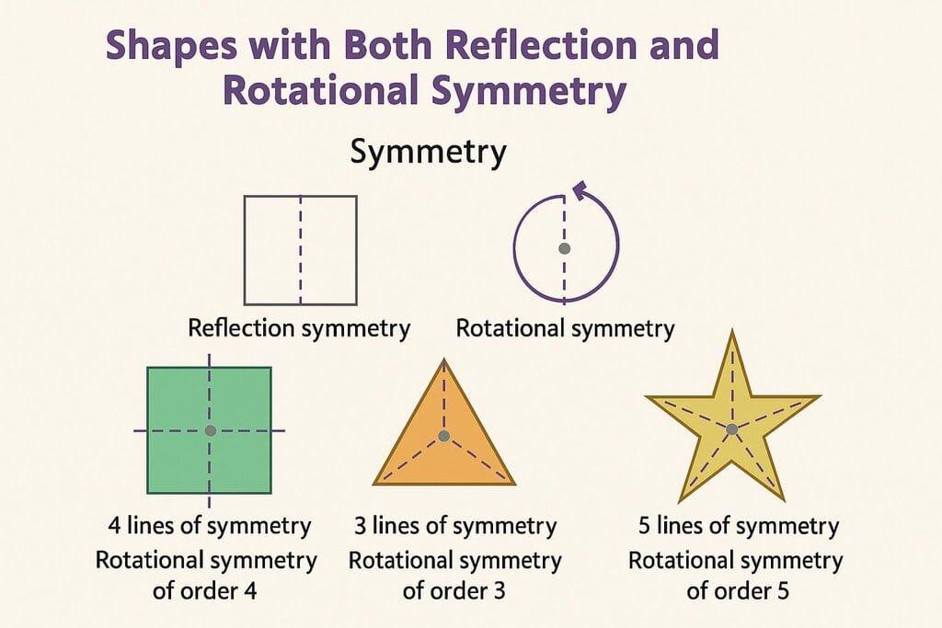
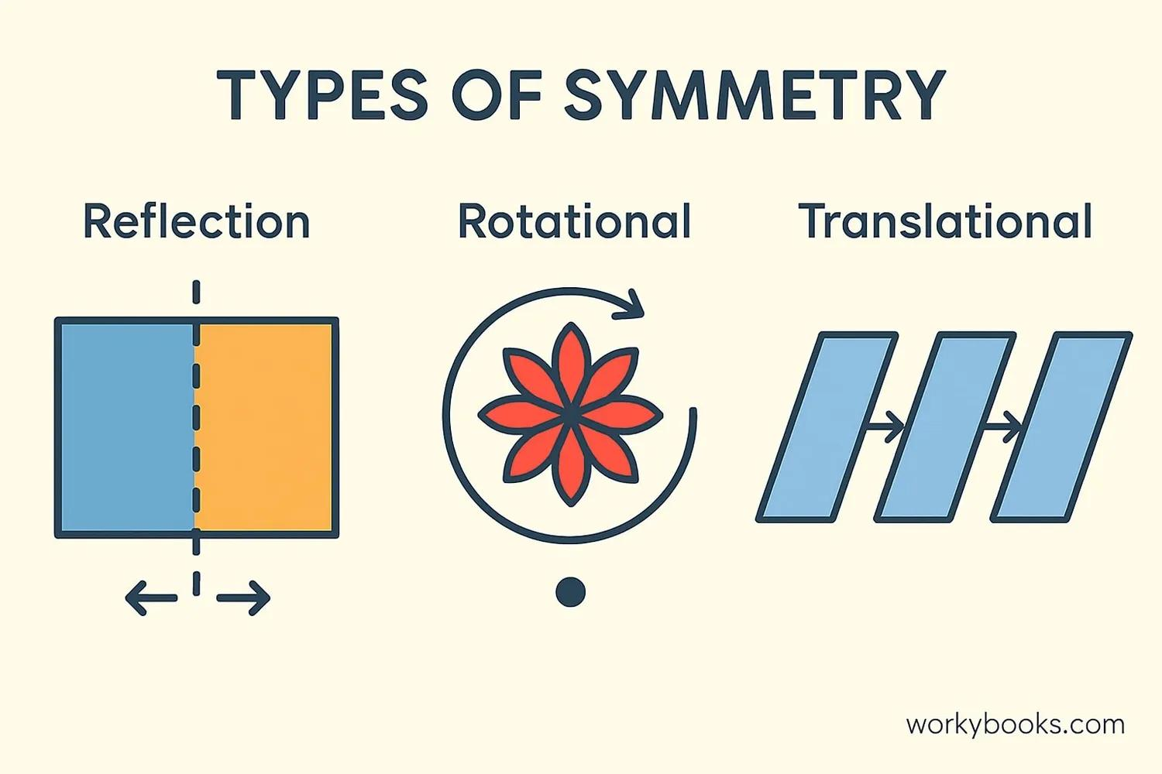
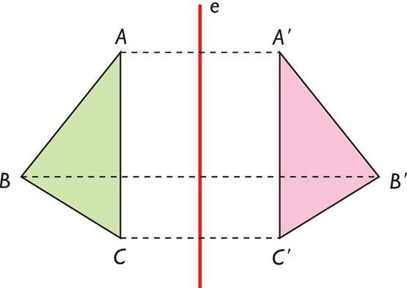

Composition of Transformations
# Source: AI Source: Provided by: [Data Path: Persons Table -> ID Column: 1, Name_En Column: Motasem Essam] -> From: [ChatGPT] on [7/25/2026]
Two or more transformations can be performed one after another.
This is called a composition of transformations.
For example:
$$\text{Reflection}→\text{Translation}$$
or:
$$\text{Rotation}→\text{Dilation}$$
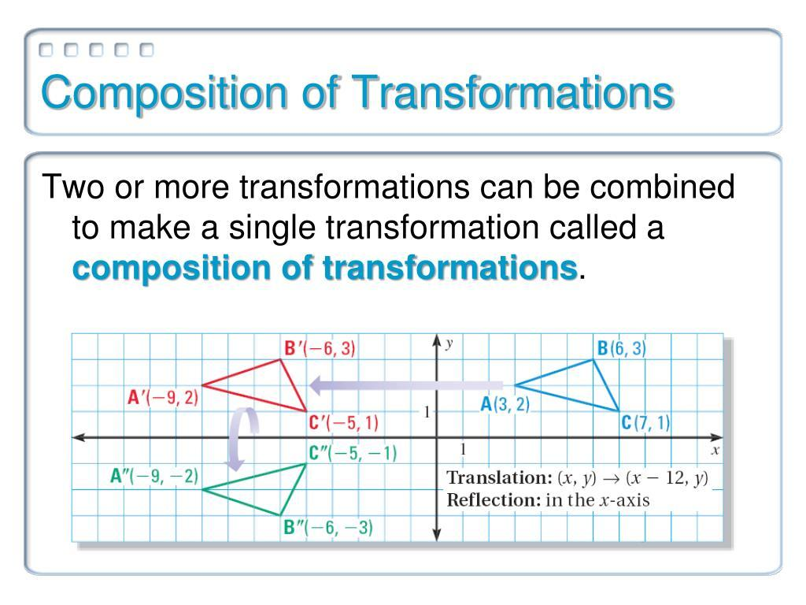
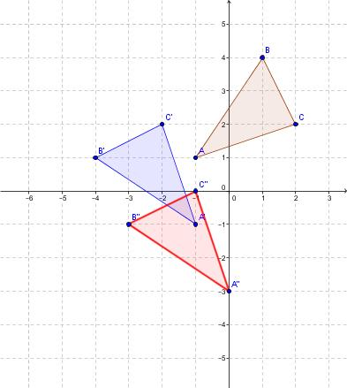
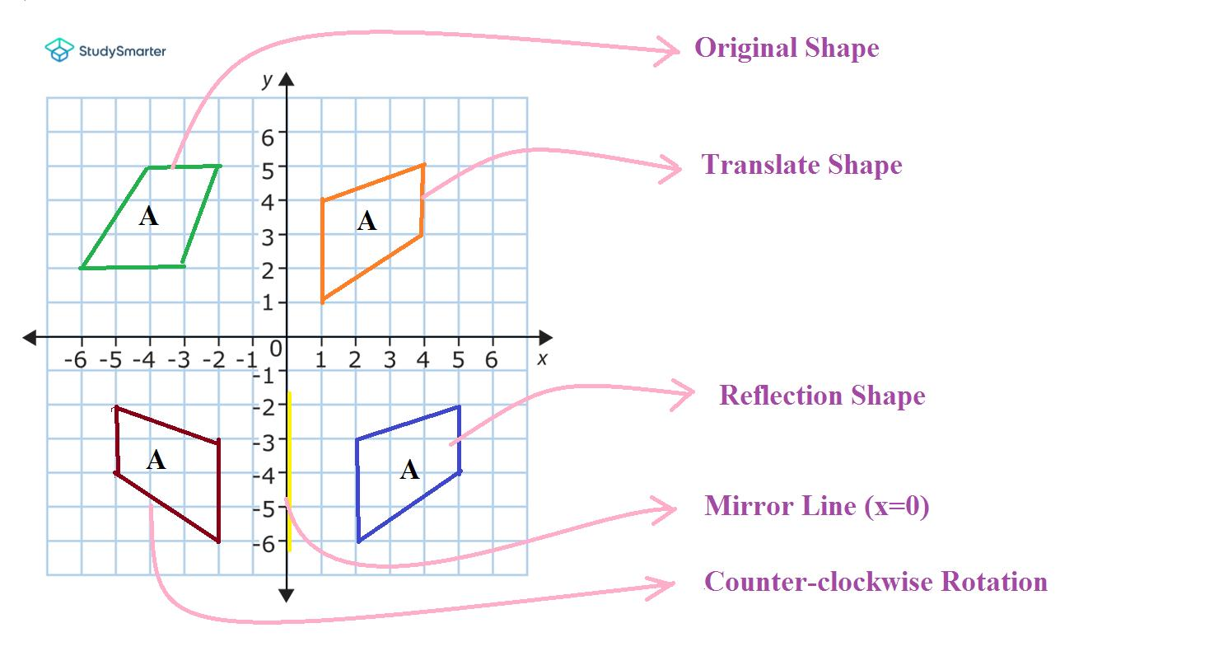
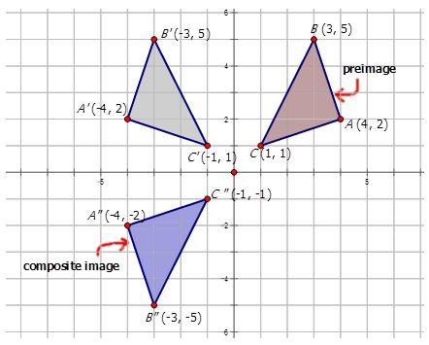
The final position of the figure depends on the transformations and their order.

Inverse Transformations
# Source: AI Source: Provided by: [Data Path: Persons Table -> ID Column: 1, Name_En Column: Motasem Essam] -> From: [ChatGPT] on [7/25/2026]
An inverse transformation reverses the effect of a transformation.
Examples:
- Translation right → Translation left.
- Rotation clockwise → Rotation counterclockwise by the same angle.
- Reflection → The same reflection.
- Dilation by $k$ → Dilation by $\frac{1}{k}$.
For example, if:
$$\left(x,y\right)→\left(x+5,y\right)$$
then the inverse is:
$$\left(x,y\right)→\left(x-5,y\right)$$

Real-World Examples
# Source: AI Source: Provided by: [Data Path: Persons Table -> ID Column: 1, Name_En Column: Motasem Essam] -> From: [ChatGPT] on [7/25/2026]
Geometric transformations appear in:
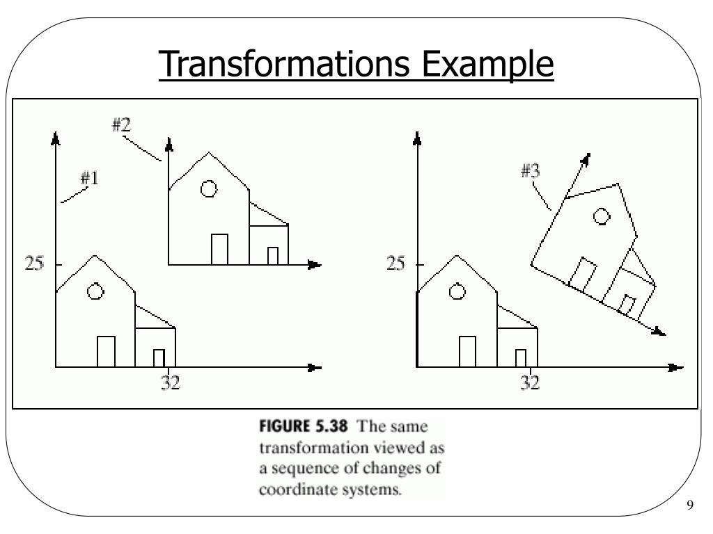
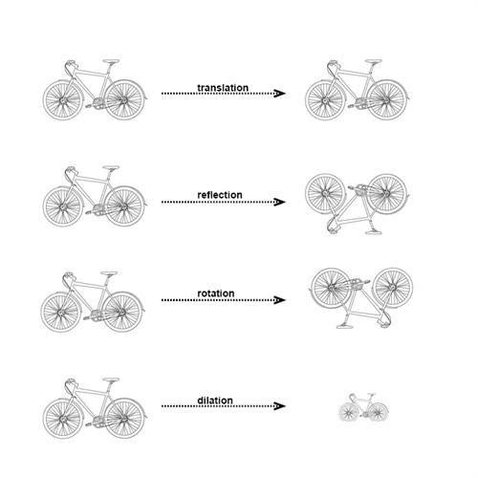
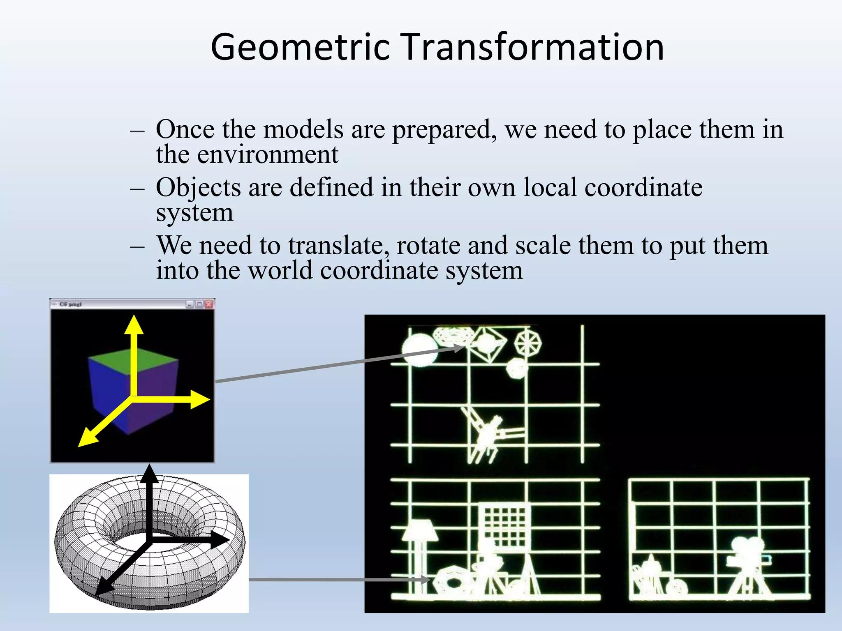
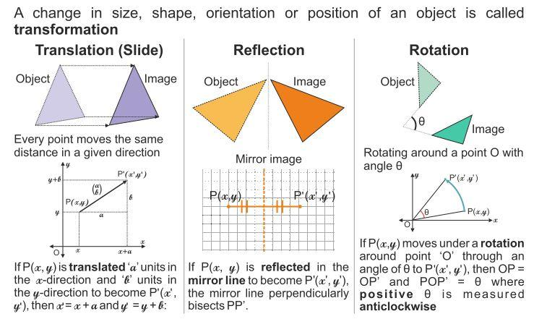
- Computer graphics.
- Animation.
- Video games.
- CAD.
- Architecture.
- Engineering.
- Robotics.
- Manufacturing.
- Map making.
- Image processing.
- 3D modeling.
- Pattern design.
Examples include:
- Moving an object across a screen → Translation.
- Turning a wheel → Rotation.
- Creating a mirror image → Reflection.
- Enlarging a drawing → Dilation.

Applications
# Source: AI Source: Provided by: [Data Path: Persons Table -> ID Column: 1, Name_En Column: Motasem Essam] -> From: [ChatGPT] on [7/25/2026]
Geometric transformations are important in:
- Plane Geometry
- Coordinate Geometry
- Linear Algebra
- Computer Graphics
- CAD
- Animation
- Robotics
- Engineering
- Architecture
- Computer Vision
- Image Processing
- Game Development
- Manufacturing

Advantages
# Source: AI Source: Provided by: [Data Path: Persons Table -> ID Column: 1, Name_En Column: Motasem Essam] -> From: [ChatGPT] on [7/25/2026]
Studying geometric transformations helps to:
- Understand how figures move.
- Analyze changes in position.
- Understand symmetry.
- Compare geometric figures.
- Determine congruence.
- Determine similarity.
- Solve coordinate geometry problems.
- Model movement mathematically.
- Create computer-generated graphics.
- Design and manipulate objects accurately.

Limitations
# Source: AI Source: Provided by: [Data Path: Persons Table -> ID Column: 1, Name_En Column: Motasem Essam] -> From: [ChatGPT] on [7/25/2026]
Geometric transformations:
- May require coordinate systems for precise calculations.
- Can become complicated when multiple transformations are combined.
- Dilation changes dimensions and therefore cannot preserve all measurements.
- Real-world transformations may involve additional physical constraints not represented by ideal geometry.

Comparison with Related Concepts
# Source: AI Source: Provided by: [Data Path: Persons Table -> ID Column: 1, Name_En Column: Motasem Essam] -> From: [ChatGPT] on [7/25/2026]
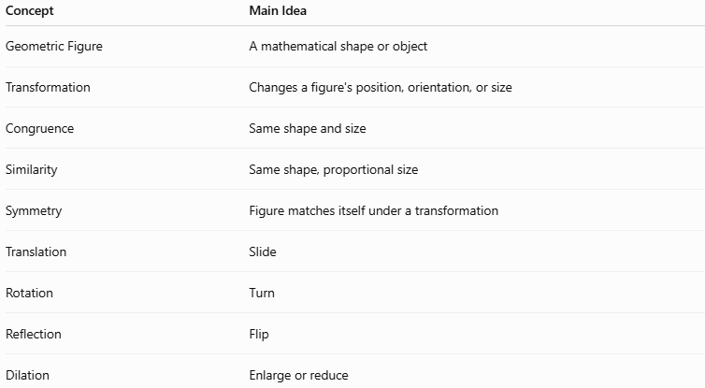
Concept | Main Idea
Geometric Figure | A mathematical shape or object
Transformation | Changes a figure's position, orientation, or size
Congruence | Same shape and size
Similarity | Same shape, proportional size
Symmetry | Figure matches itself under a transformation
Translation | Slide
Rotation | Turn
Reflection | Flip
Dilation | Enlarge or reduce

Key Points
# Source: AI Source: Provided by: [Data Path: Persons Table -> ID Column: 1, Name_En Column: Motasem Essam] -> From: [ChatGPT] on [7/25/2026]
- A Geometric Transformation changes a figure according to mathematical rules.
- The original figure is called the preimage.
- The resulting figure is called the image.
- The four fundamental transformations are:
  - Translation
  - Rotation
  - Reflection
  - Dilation
- Translation, rotation, and reflection are rigid transformations.
- Dilation changes the size while preserving the shape.
- Rigid transformations produce congruent figures.
- Dilation produces similar figures when the scale factor is not (1).
- Transformations are fundamental to symmetry, coordinate geometry, computer graphics, engineering, and design.

Conclusion
# Source: AI Source: Provided by: [Data Path: Persons Table -> ID Column: 1, Name_En Column: Motasem Essam] -> From: [ChatGPT] on [7/25/2026]
Geometric Transformations are mathematical operations used to move, rotate, reflect, enlarge, or reduce geometric figures. The four fundamental transformations are translation, rotation, reflection, and dilation. Translation, rotation, and reflection preserve the size and shape of a figure, while dilation changes its size while preserving its shape. Geometric transformations provide an essential foundation for understanding congruence, similarity, symmetry, coordinate geometry, computer graphics, engineering, architecture, robotics, and design.

